PRATICAL ELEVEN: HYPOTHESIS TESTING WITH SPSS

1. Generate a one-sample problem and corresponding data.
2. Set the hypothesis with the hypothesized mean for the problem.
3. Give a step by step procedure for running the analysis with SPSS.
4. Give the SPSS data structure for the analysis and run the analysis.
5. Give the decision rule and conclusion based on the output of your analysis.
6. Generate a two-sample problem and corresponding data.
7. Set the hypothesis for the problem.
8. Give a step by step procedure for running the analysis with SPSS.
9. Give the SPSS data structure for the analysis and run the analysis.
10. Give the decision rule and conclusion based on the output of your analysis.

SOLUTION

ONE-SAMPLE PROBLEM AND CORRESPONDING DATA

The CGPA of 15 students in a Department.

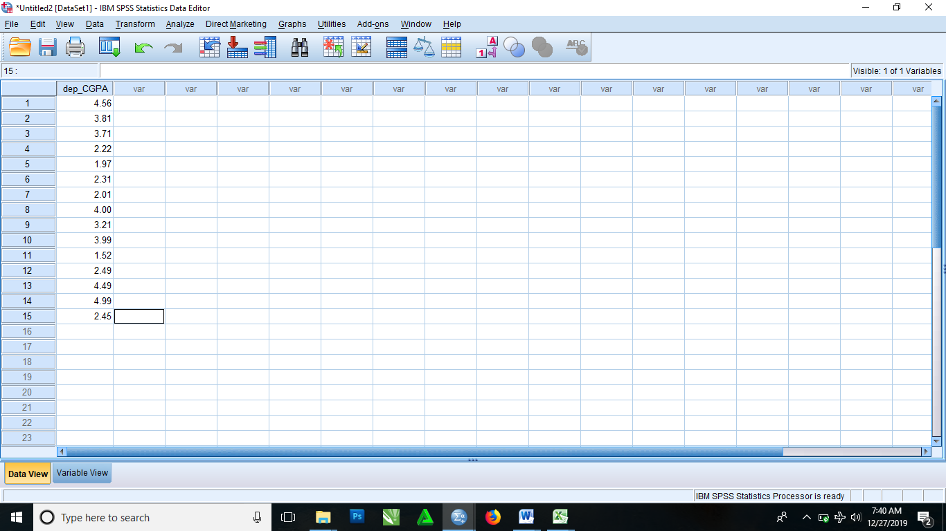

Null Hypothesis, Ho: **They did not score a statistically significant different from 4.0**.

Alternative Hypothesis, Hi: **They score a statistically significant different from 4.0**.

After inputting your data into SPSS, you then follow the following procedure:

* From the menus, select

Analyze > One-sample T Test

* Then it brings you to a dialog box where from the left box there is a variable which you click and drag to the Test Variable(s), and then you drop.
* Select Options. It then brings you to a dialog box where you leave all settings as it default setting.
* Click Continue
* Put your Test Value to be 4
* Click OK.

|  |  |  |  |  |  |  |
| --- | --- | --- | --- | --- | --- | --- |
| **One-Sample Test** | | | | | | |
|  | Test Value = 4 | | | | | |
| t | df | Sig. (2-tailed) | Mean Difference | 95% Confidence Interval of the Difference | |
| Lower | Upper |
| dep_CGPA | -2.860 | 14 | .013 | -.81800 | -1.4315 | -.2045 |

Since, there was a statistically significant difference between means (p < .05). We therefore can reject the Null Hypothesis, Ho and accept the Alternative Hypothesis, Hi.

TWO SAMPLE PROBLEM AND CORRESPONDING DATA

First year CGPA is greater than the second year CGPA. In order to prove this point, the CGPA of 15 students in their first year and second year report analysis was carried out to know whether the claim is true or not.

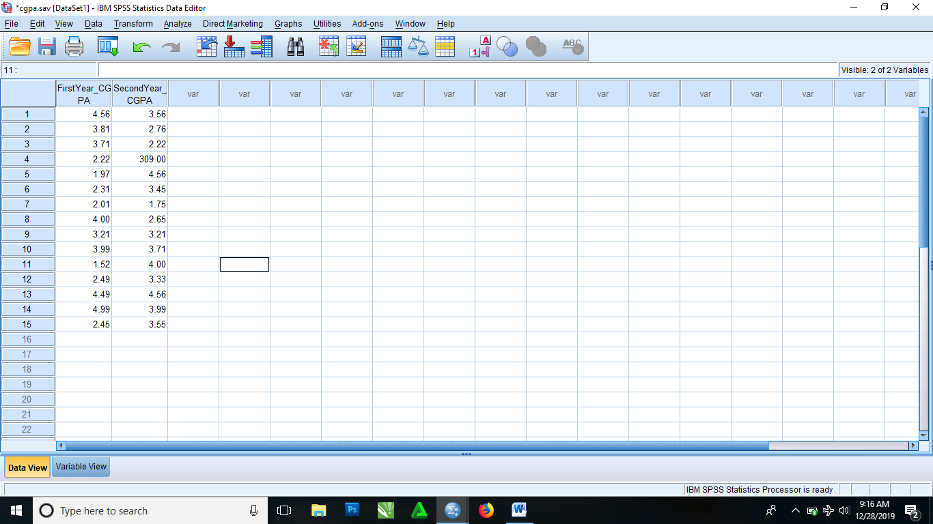

Null Hypothesis, Ho: The first year CGPA is greater than the second year CGPA.

Alternative Hypothesis, Hi: The first year CGPA is lesser than the second year CGPA.

After inputting your data and editing every necessary details. To do the 2 sample analysis you follow the following steps:

From the menus, select

Analyze > Compare means > Paired-sample T Test

Then it brings you to a dialog box. From the left box there is a list of variables present there, you then click and drag the variables in question to Paired Variables box on the right side (you drop the first semester CGPA to the variable1 and second semester CGPA to Variable2).

Click Options. Then leave it as it default settings and click Continue.

Click OK.

|  |  |  |  |  |  |  |  |  |  |
| --- | --- | --- | --- | --- | --- | --- | --- | --- | --- |
| **Paired Samples Test** | | | | | | | | | |
|  | | Paired Differences | | | | | t | df | Sig. (2-tailed) |
| Mean | Std. Deviation | Std. Error Mean | 95% Confidence Interval of the Difference | |
| Lower | Upper |
| Pair 1 | FirstYear_CGPA - SecondYear_CGPA | -20.57133 | 79.18768 | 20.44617 | -64.42401 | 23.28134 | -1.006 | 14 | .331 |
|  |  |  |  |  |  |  |  |  |  |